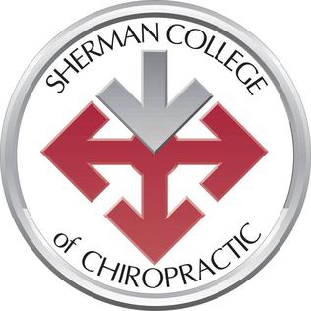
SHERMAN COLLEGE OF CHIROPRACTIC
Sherri Buckner - Admissions Representative
MONDAY 01-28-19
10:30-12:30PM
2ND FLOOR BURGESS STUDENT CENTER
Sponsored by SMC Career and Transfer Services BSC 205

